1.

EMISSIONS PER CAPITA for Canada: 17.72

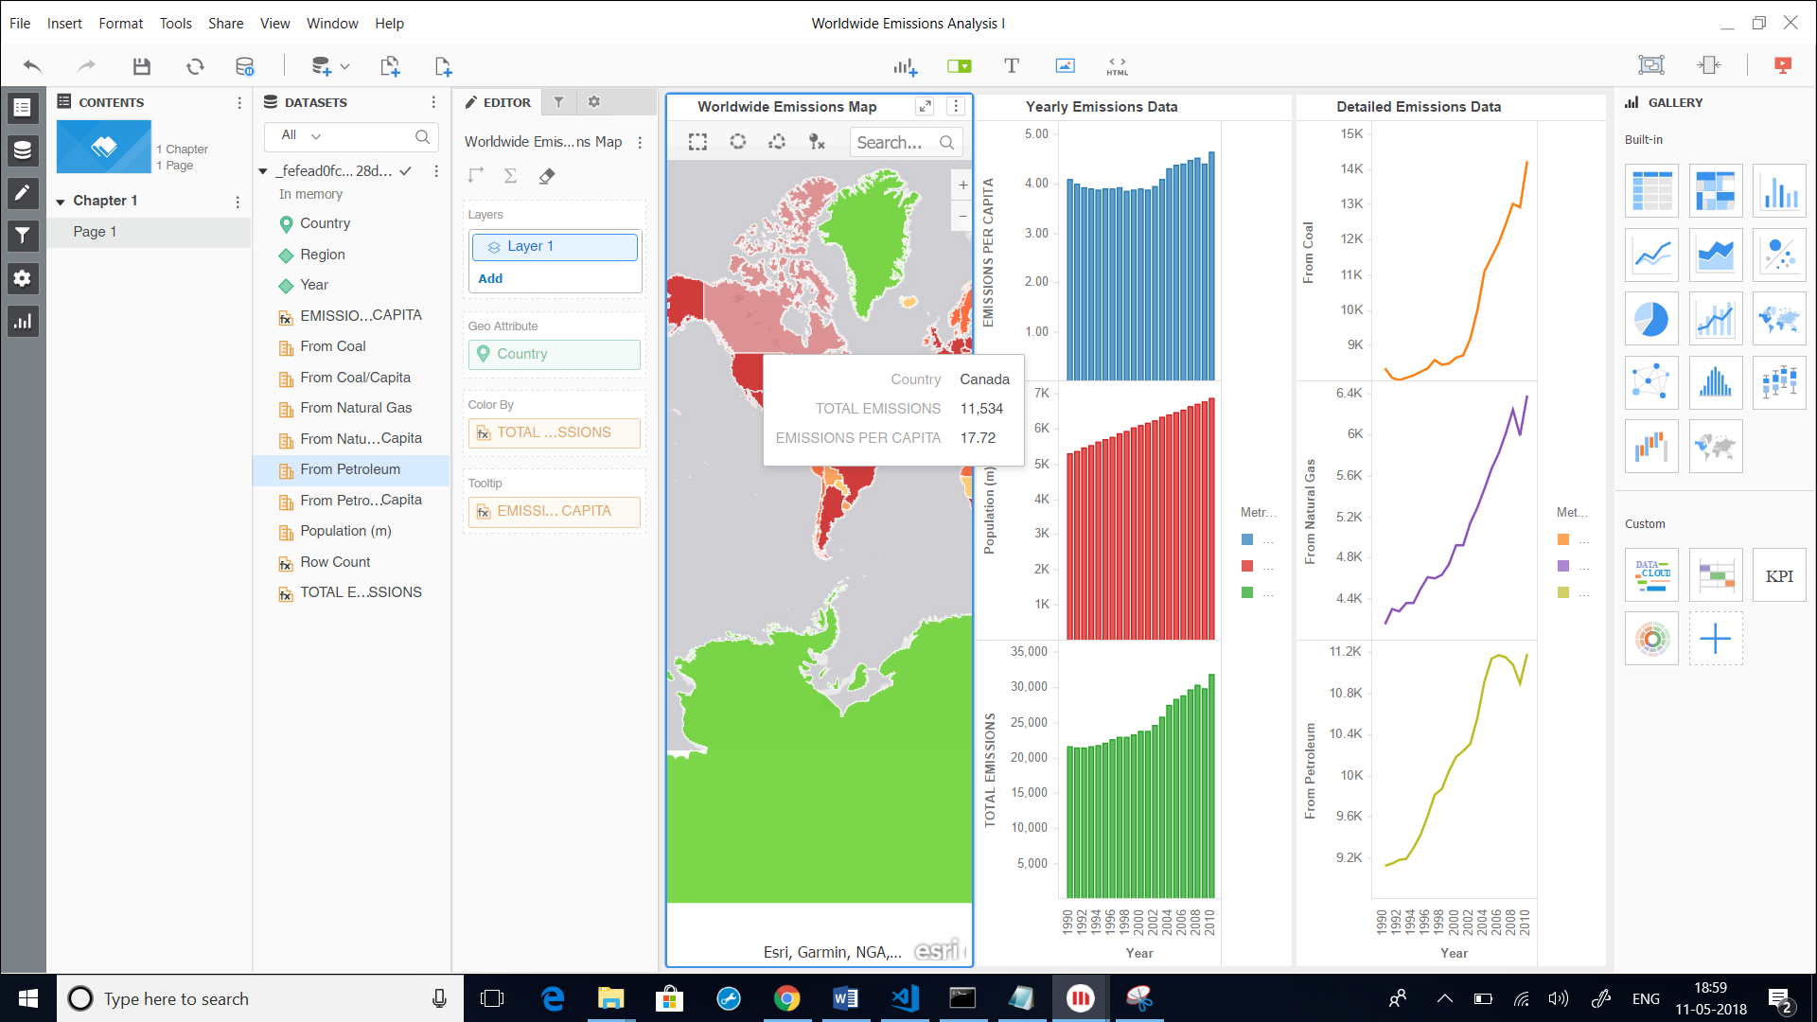

2.

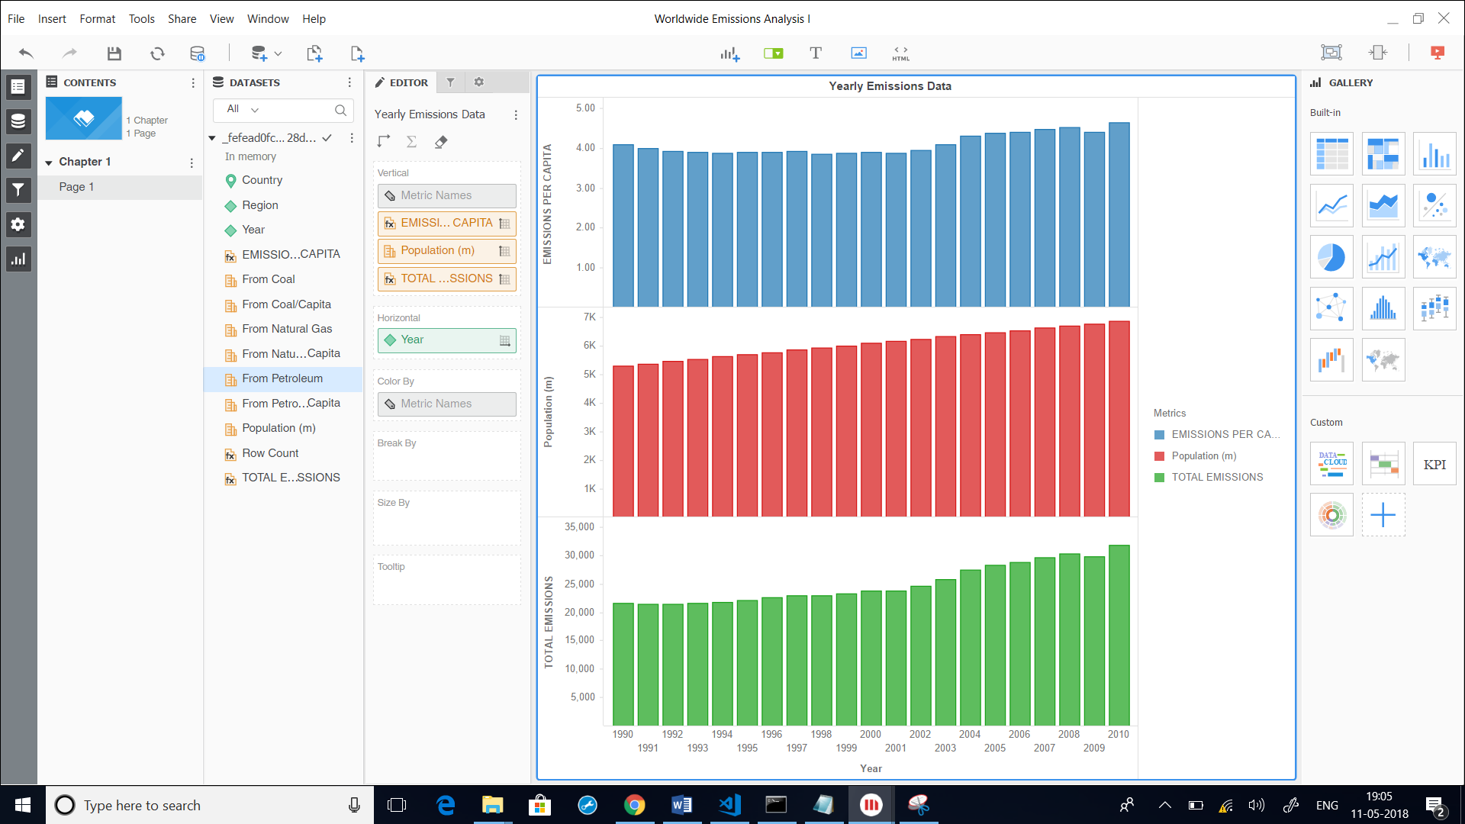

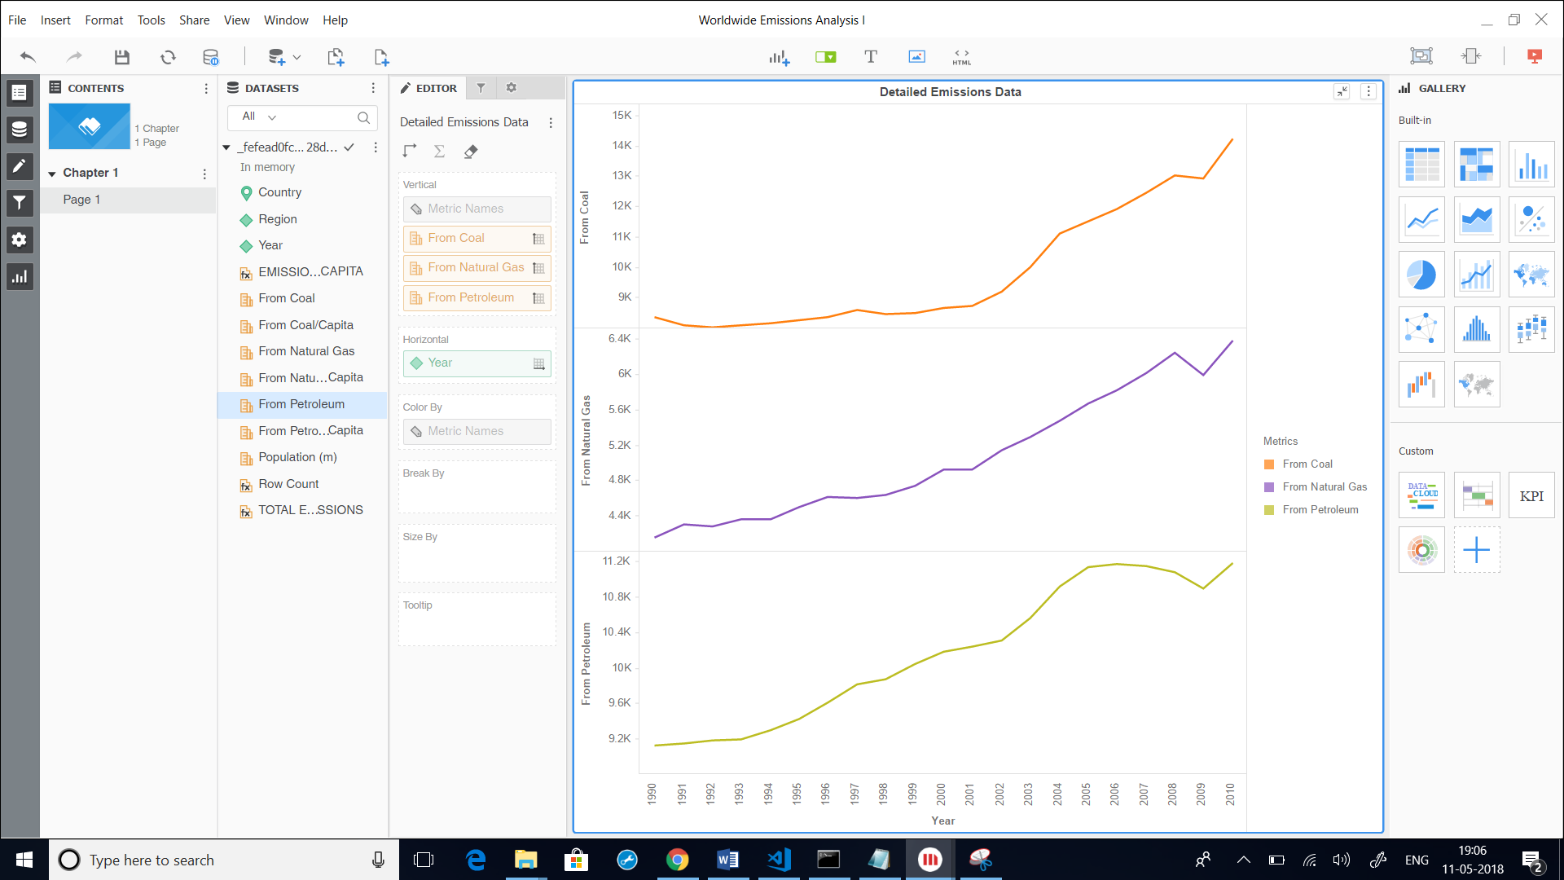

Overall trend says that as population is increasing, the total emissions is increasing. This was however an exception in the year 2009. Emissions from all the three fuel sources in also increasing over the years(except 2009 when there was a fall in all 3).

3.

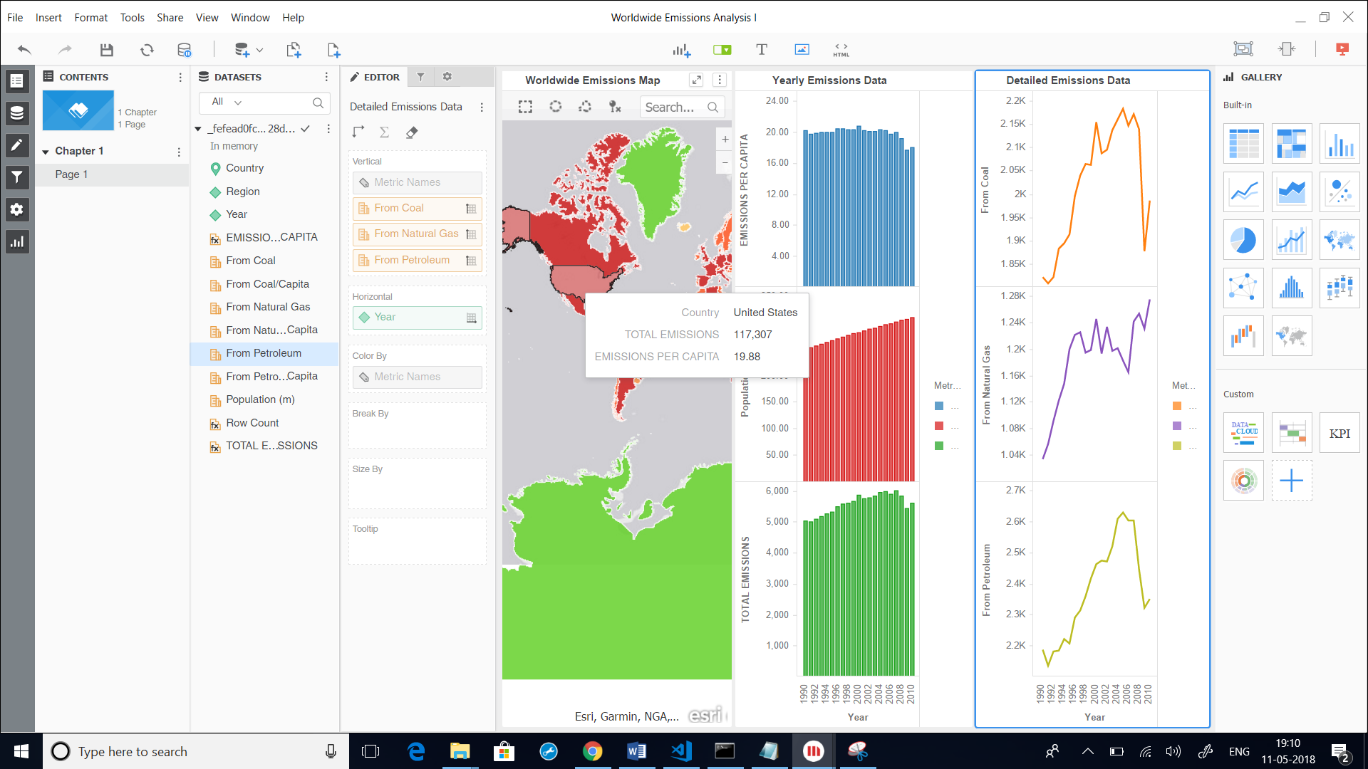

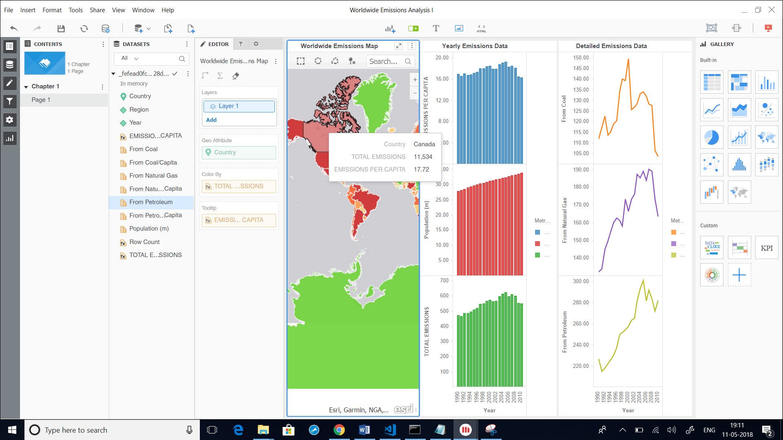

The great depression and recession period in 2009 is the cause of decrease in pollution in 2009.